Dynamic model

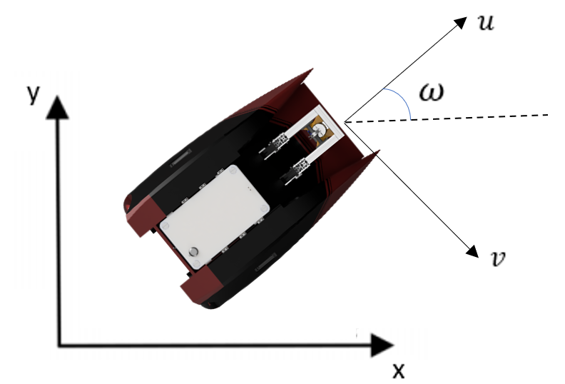

Figure : Barbaros ida kordinat sistemi

Figure 1 shows the Earth-fixed inertial frame fig and the body-fixed frame fbg. The positive direction of the X-axis of frame fbg coincides with the USV heading direction, and the origin locates at the barycenter of USV[2].

$$\dot{x}=u*cosω-v*sinω$$

$$\dot{y}=u*sinω+v*cosω$$

$$\dot{ψ}=r$$

|  |  |  |  |  |
| --- | --- | --- | --- | --- |
| Degree of Freedom | | Forces and Moments($τ$) | Velocities($ν$) | Pozisyon ( $η)$ |
| Translational Motion | x(Surge) | X | u | x |
| y(Sway) | Y | v | y |
| z(Heave) | Z | w | z |
| Rotational Motion | x(roll) | K | p | $$φ$$ |
| y(pitch) | M | q | $$θ$$ |
| z(yaw) | N | r |  |

|  |  |
| --- | --- |
| Sembol | Açıklama |
| 𝑋𝑢̇ | X-axis added mass caused by 𝑢̇ |
| 𝑌𝑣̇ | Y-axis added mass caused by 𝑣̇ |
| 𝑁𝑟̇ | N-axis added mass caused by 𝑟̇ |
| 𝑋𝑢 | X-axis linear damper caused by 𝑢 |
| 𝑌𝑣 | Y-axis linear damper caused by 𝑣 |
| 𝑁𝑟 | N-axis linear damper caused by 𝑟 |
| 𝐼𝑧 | Inertial moment with respect to Ob Zb |
| 𝑋|𝑢|𝑢 | X-axis non-linear damper caused by 𝑢 |
| 𝑌|𝑣|𝑣 | Y-axis non-linear damper caused by 𝑣 |
| 𝑌|𝑣|𝑟 | Y-axis non-linear damper caused by 𝑣 and 𝑟 |
| 𝑌|𝑟|𝑣 | Y-axis non-linear damper caused by 𝑟 and 𝑣 |
| 𝑁|𝑣|𝑣 | N-axis non-linear damper caused by 𝑣 |
| 𝑁|𝑟|𝑣 | N-axis non-linear damper caused by 𝑟 and 𝑣 |
| 𝑁|𝑣|𝑟 | N-axis non-linear damper caused by 𝑣 and 𝑟 |
| 𝑁|𝑟|𝑟 | N-axis non-linear damper caused by 𝑟 |
| 𝜌 | Sea water density |
| 𝐿 | Length of the vessel |
| 𝐵 | Breadth of the vessel |
| 𝑇 | Draft of the vessel |
| 𝜌𝑎 | Air density |
| 𝐴𝐹𝑤 | Wind Frontal projected area |
| 𝐴𝐿𝑤 | Wind Lateral projected area |
| 𝐴𝐹𝑐 | Water Frontal projected area |
| 𝐴𝐿𝑐 | Water Lateral projected area |
| 𝐿𝑂𝐴 | Vessel length of overall |
| 𝐻𝐹𝑤 | Centroid of 𝐴 𝐹𝑤 above waterline |
| 𝐻𝐿𝑤 | Centroid of 𝐴𝐿𝑤 above waterline |
| 𝐶𝑥(𝛾𝑤) | X-axis wind coefficient |
| 𝐶𝑦(𝛾𝑤) | Y-axis wind coefficient |
| 𝐶𝑁(𝛾𝑤) | Yaw-axis wind coefficient |

USV is ship that can move without human to drive it or called autonomous .The general dynamic model of USV is expressed in 6-degree of freedom. The following are the general USV dynamic model equations:

𝑀𝑣̇ = −𝐶(𝑣)𝑣 − 𝐷(𝑣)𝑣 − 𝑔(𝜂) + 𝜏 + 𝜏𝐸

Where ν = [u, v, w, p, q, r]T, = [x, y, z,,, ]T, τ = [X, Y, Z, K, M, N]T and

𝑀, 𝐶(𝑣), 𝐷(𝑣), 𝑔(𝜂), 𝜏 represent the inertia matrix, Coriolis and centripetal terms matrix, damping matrix, gravitational forces and moments and control inputs, respectively.

with,

𝑀 = 𝑀𝑅𝐵 + 𝑀𝐴

𝐶(𝑣) = 𝐶𝑅𝐵(𝑣) + 𝐶𝐴(𝑣)

𝐷(𝑣) = 𝐷 + 𝐷𝑛 (𝑣)

$$τ_{E}= τ_{E}^{cu} +{ τ}_{E}^{wa} +{ τ}_{E}^{wi}$$

In this research, several assumptions were used so that the USV dynamics model could be simplified into a model with 3-degree of freedom. The following are the assumptions taken in this research:

a. Roll, pitch, and heave movements are ignored.

b. The vessel has a homogeneous mass distribution and symmetry in the xz-plane so 𝐼𝑥𝑦 = 𝐼𝑦𝑧 = 0.

c. The center of gravitational force and the center of buoyancy are located in one vertical line, that is the z-axis.

With the aforementioned assumptions, the equation of the USV dynamics model becomes as follows:

𝑀𝑣̇ = −𝐶(𝑣)𝑣 – (𝐷 + 𝐷𝑛 (𝑣) )𝑣 − 𝑔(𝜂) + 𝜏 + 𝜏𝐸

From the above equation, by ignoring external disturbances, the mathematical equations for each coordinate axis are obtained as follows[1]:

$$\dot{u}=\frac{m-Y_{\dot{v}}}{m-X_{\dot{u}}}vr-\frac{X_{u}}{m-X_{\dot{u}}}u-\frac{X_{\left|u\right|u}}{m-X_{\dot{u}}}+\frac{1}{m-X_{\dot{u}}}τ_{u}$$

$$\dot{v}=\frac{X_{\dot{u}}-m}{m-Y_{\dot{v}}}ur-\frac{Y_{v}}{m-Y_{\dot{v}}}v-\frac{Y_{\left|v\right|v}}{m-Y_{\dot{v}}}\left|v\right|v-\frac{Y_{\left|r\right|v}}{m-Y_{\dot{v}}}\left|r\right|v-\frac{Y_{\left|v\right|r}}{m-Y_{\dot{v}}}|v|r$$

$$\dot{r}=\frac{Y_{\dot{v}}-X_{\dot{u}}}{I_{z}-N_{\dot{r}}}uv-\frac{N_{r}}{I_{z}-N_{\dot{r}}}r-\frac{N_{\left|v\right|v}}{I_{z}-N_{\dot{r}}}\left|v\right|v-\frac{N_{\left|r\right|v}}{I_{z}-N_{\dot{r}}}\left|r\right|v-\frac{N_{\left|v\right|r}}{I_{z}-N_{\dot{r}}}\left|v\right|r-\frac{N_{\left|r\right|r}}{I_{z}-N_{\dot{r}}}\left|r\right|r+\frac{1}{I_{z}-N_{\dot{r}}}τ_{r}$$

Thrust Force Acting on the USV

the control force and moment can be defined by the following Equation (6) considering the arrangement of the thrust:

$$τ_{thrust}=\left[\begin{matrix}{X_{thrust}}_{s} \\ {N_{thrust}}_{s}\end{matrix}\right]=\left[\begin{matrix}T_{port}+T_{stdb} \\ {(T}_{port}+T_{stdb})*\frac{B}{2}\end{matrix}\right]$$

Wind Load

Disturbances acting on a USV include wave load, current load, and wind load. Such disturbances can cause drift motion of the USV. These disturbances need to be taken into consideration to more accurately describe the motion. In this study, the load due to the waves was not considered because the load caused by the wind was more dominant than the load caused by the waves under the same sea conditions. The magnitude of the force and moment acting on the USV was calculated using the Fossen wind load model [6]. The following Equation (7) shows the force and moment due to wind load:

$$τ_{wind}=\left[\begin{matrix}X_{wind} \\ Y_{wind} \\ N_{wind}\end{matrix}\right]=\left[\begin{matrix}\frac{1}{2}C_{x}\left(γ_{R}\right)ρ_{w}V_{R}^{2}A_{T} \\ \frac{1}{2}C_{γ}\left(γ_{R}\right)ρ_{w}V_{R}^{2}A_{L} \\ \frac{1}{2}C_{N}\left(γ_{R}\right)ρ_{w}V_{R}^{2}A_{L}L\end{matrix}\right]$$

$$C_{x}\left(ψ_{R}\right)= -C_{x}\cos\left(ψ_{R}\right),$$

$$C_{y}\left(ψ_{R}\right)= C_{y}\sin\left(ψ_{R}\right),$$

$$C_{N}(ψ_{R}) = C_{z} sin({2ψ}_{R})$$

where ,Cx , Cy , CN are wind load coefficients, and $ρ_{w}$ is the air density. AR ,AL ,L refer to the frontal projected area, the lateral projected area, and the horizontal length from the font end of the USV the end of aft end, respectively.

Current Load

Due to a variety of factors such as wind, waves or ocean temperature differences, currents, and so on, very sophisticated forms of current can occur in irregular shapes, complicating the model’s precision mathematically to account for effects of current. Therefore, it is common to model current in marine environment using the first Gauss-Markov process [6]. In general, the equation of motion of a USV considering the effects of a current instead of directly applying the forces and moments applied to the hull by the current directly to the equation of motion replaces the relative velocity of the current and the USV to a previously derived motion equation. It is used as a method. The current velocity () in earth-fixed frame defined as shown in Figure 5 is the body-fixed reference frame of the USV and can be converted as shown in Equation below:

$$u_{c}=V_{c}\cos\left(β-ψ\right)$$

$$v_{c}=V_{c}\sin\left(β-ψ\right)$$

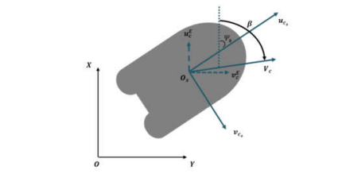

Figure . Defined Velocity (Vc) and direction (β) of the current

[1] Setiawan, F & Kadir, R & Gamayanti, N & Santoso, A & Bilfaqih, Yusuf & Hidayat, Z. (2021). Dynamic modelling and controlling Unmanned Surface Vehicle. IOP Conference Series: Earth and Environmental Science. 649. 012056. 10.1088/1755-1315/649/1/012056.

[2] Wen, Naifeng & Zhang, Rubo & Liu, Guanqun & Wu, Junwei & Qu, Xingru. (2020). Online planning low-cost paths for unmanned surface vehicles based on the artificial vector field and environmental heuristics. International Journal of Advanced Robotic Systems. 17. 172988142096907. 10.1177/1729881420969076.

[3] Yan, Xun & Jiang, Dapeng & Miao, Runlong & Li, Yulong. (2021). Formation Control and Obstacle Avoidance Algorithm of a Multi-USV System Based on Virtual Structure and Artificial Potential Field. Journal of Marine Science and Engineering. 9. 161. 10.3390/jmse9020161.

[4] Sung Min Hong , Kyoung Nam Ha and Joon-Young Kim.(2020). Dynamics Modeling and Motion Simulation of USV/UUV with Linked Underwater Cable

[5]<https://doi.org/10.1016/j.oceaneng.2020.107438>

[6] Fossen, T.I. Guidance and Control of Ocean Vehicles. Vol 199. No. 4. New York: Wiley, 1994.